Hashtag: #dchealthcareers
Size: 1200 x 628
Link: https://dchealthcareers.org/looking-for-a-new-career/

Link: https://dchealthcareers.org/do-i-have-the-right-skills/

Link: https://dchealthcareers.org/pharmacy-technician/

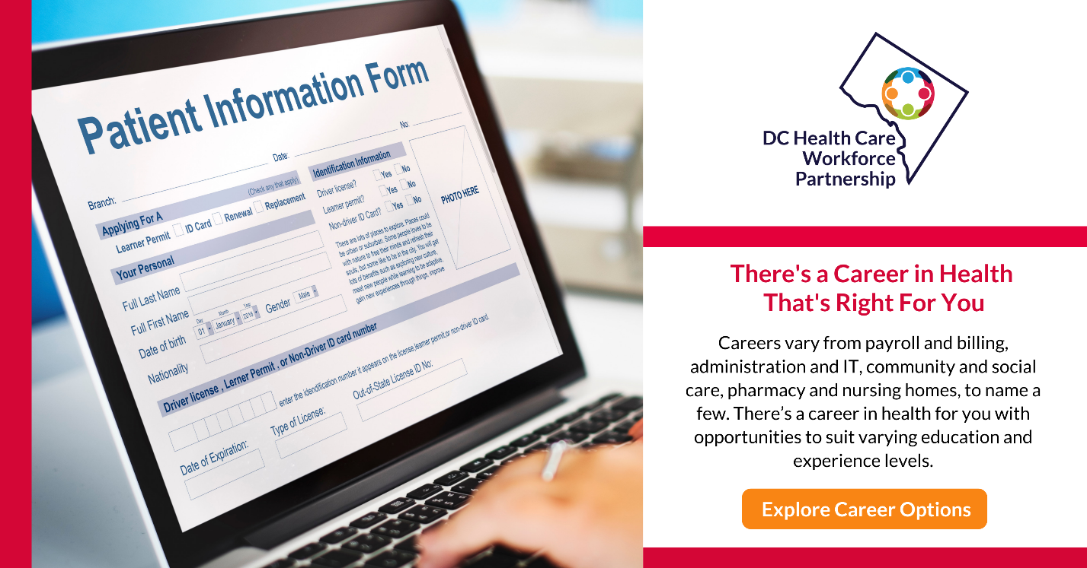
Link: https://dchealthcareers.org/do-i-have-the-right-skills/

Link: https://dchealthcareers.org/home-health-aide/

Link: https://dchealthcareers.org/heath-informatics/

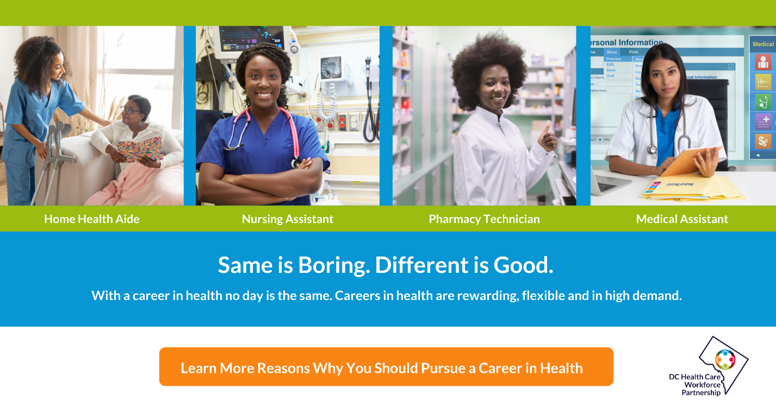 Link: https://dchealthcareers.org/certified-medical-assistant/

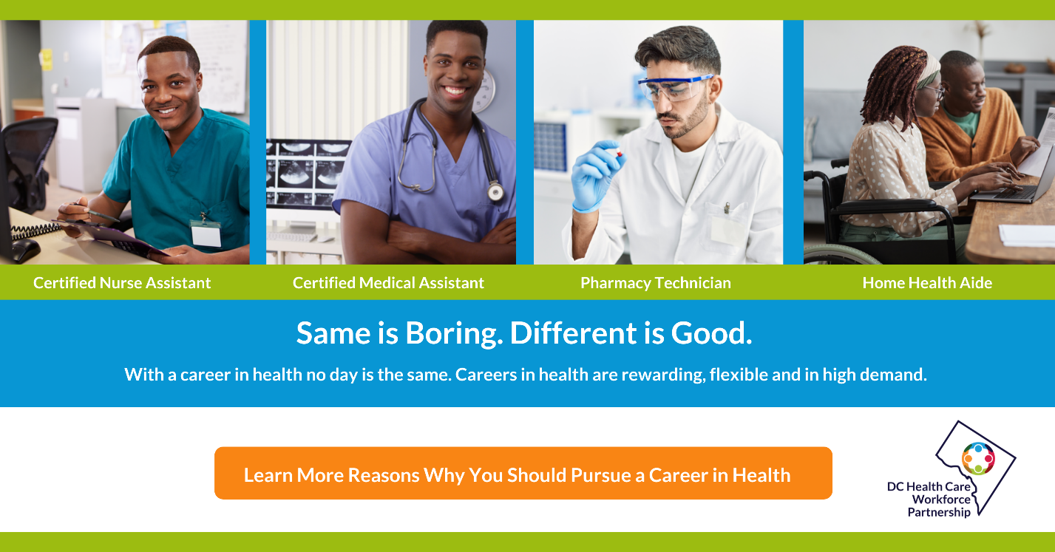
Link: https://dchealthcareers.org/licensed-practical-nurse/

Link: https://dchealthcareers.org/looking-for-a-new-career/

Link: https://dchealthcareers.org/home-health-aide/

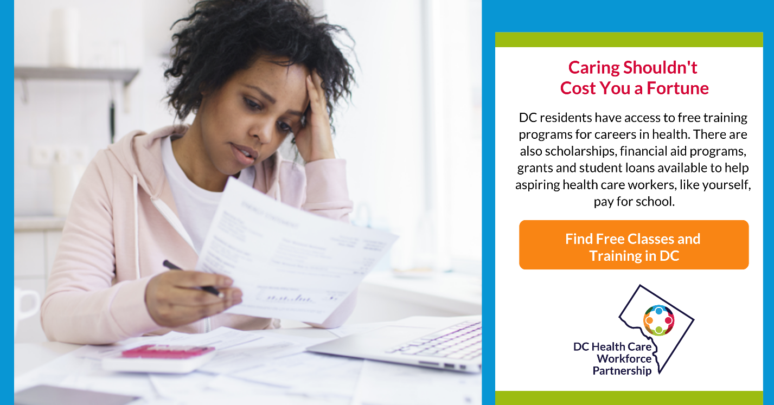
Link: https://dchealthcareers.org/start-your-career-in-health/

Link: https://dchealthcareers.org/do-i-have-the-right-skills/

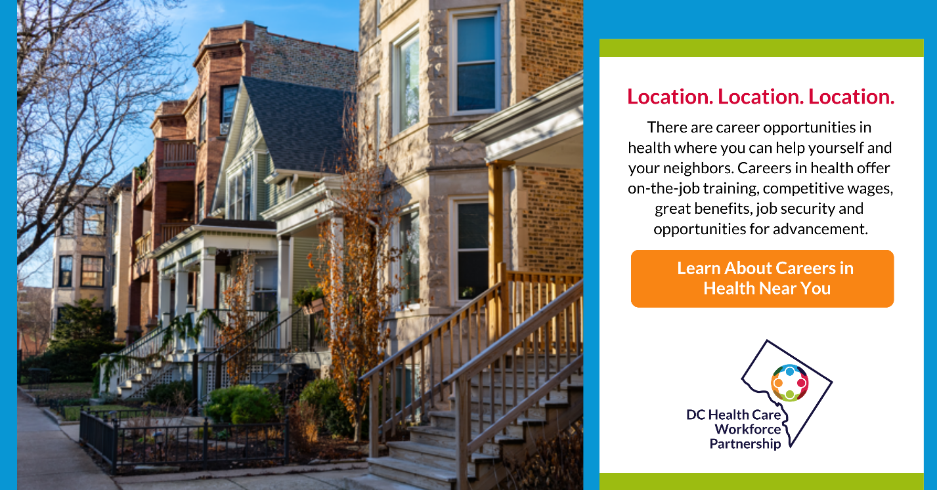
Link: https://dchealthcareers.org/find-your-next-opportunity/

Link: https://dchealthcareers.org/find-your-next-opportunity/

Link: https://dchealthcareers.org/start-your-career-in-health/

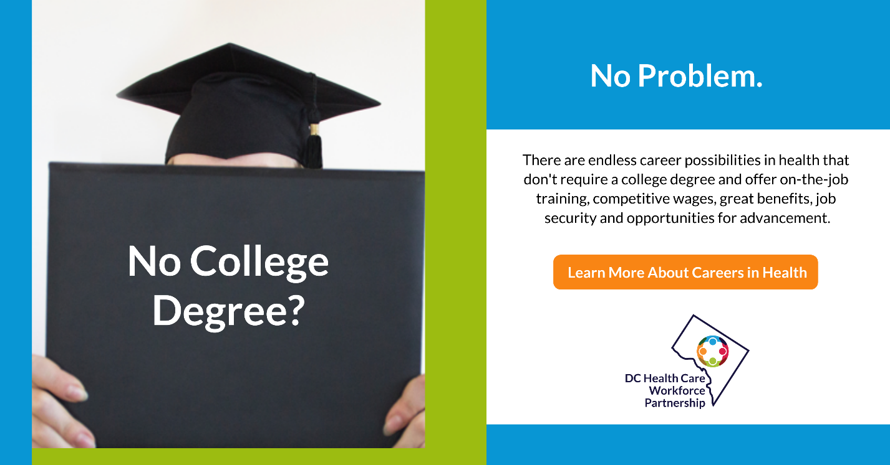
Link: https://dchealthcareers.org/

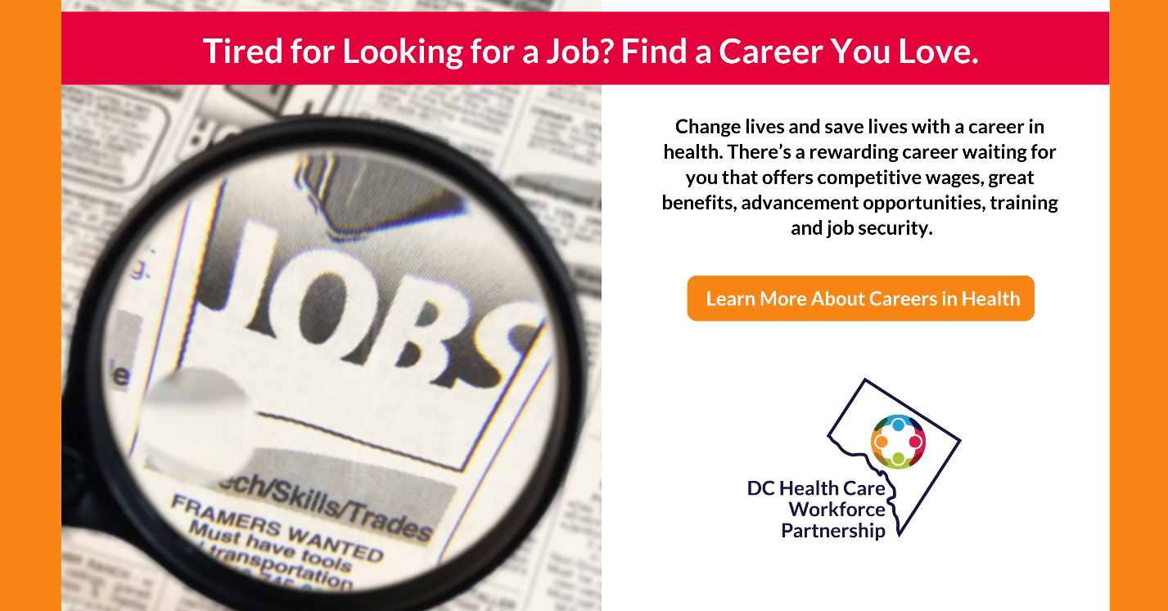
Link: https://dchealthcareers.org/looking-for-a-new-career/

Link: https://dchealthcareers.org/looking-for-a-new-career/

